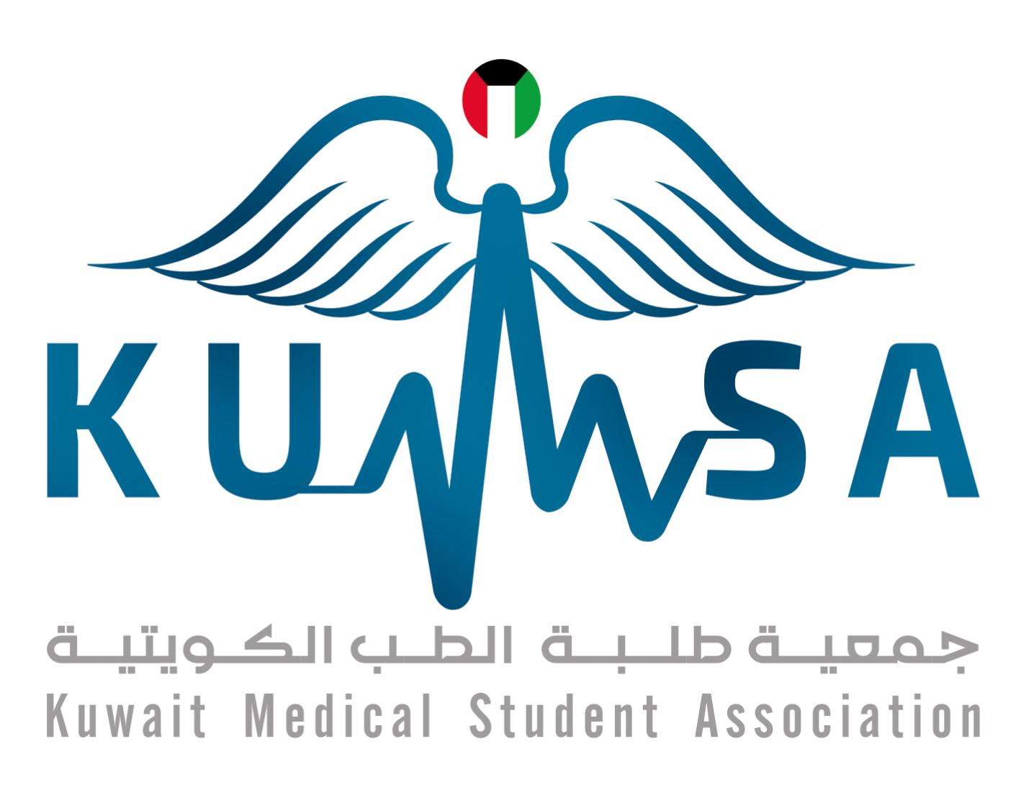

Name
Address and P.O box
Phone: / Email:
PERSONAL INFORMATION
Gender:
Date of Birth:
Place of Birth:
Nationality:
Marital Status:
EDUCATION
Degrees:
September 20XX – present Doctor of Medicine (anticipated June 20XX), Faculty of Medicine, Kuwait University, Kuwait
September 20XX – June 20XX Bachelor of Medical Sciences, Faculty of Medicine,
Kuwait University, Kuwait
August 20XX- June 20XX High School Diploma (write if Valedictorian with Honors), X School, Kuwait
Electives: (include everything in chronological order)
2019 Cardiology, X Healthcare Center, United States
2019 Radiology, X General Hospital, Canada
2019 Cardiology, Chest Diseases Hospital, Kuwait
2018 Anatomy, Dissection of the Thoracic Cavity, Kuwait University, Kuwait
Internships: (medical attendance that was not an elective)
2015 Student Ambassador Internship Program, Dasman
Diabetes Institute, Kuwait

Certifications (include things you find relevant)
2017, 2014 Safe Injections, Dasman Diabetes Institute and Kuwait Medical Specialization of Continuing Medical Education GOOD
2016 Japanese Language- Level 1A, Center for Continuing Education, Kuwait University XX
2014 Basic Life Support, Dasman Diabetes Institute and Kuwait Medical Specialization of Continuing Medical Education, Kuwait
AWARDS (include accolades in the medical field, and what you won them for)
2019 X Research Competition Poster Winner, X Conference, X Poster
Academic Distinction
2014, 2015 Certificate of Excellence awarded by Kuwait Medical Student Association, Faculty of Medicine, Kuwait University
RESEARCH (include title, supervisor, and role)
2018 X, Department of Community Medicine, Faculty of Medicine, Kuwait University
Role: First author
Mentor: X
Other Research Experience (include research in which you are not an author, but contributed nonetheless)
2015 Active Contributor, Knowledge, Attitude, Behavior, and Diabetic Practices Survey Research at Dasman Diabetes Institute, Kuwait
Mentor: Dr. Ali Ziyab
Appointments
2020 Elected X of The Organizing Committee, KuMSA Research and Innovation Conference, Kuwait

Humanitarian/Volunteer Activities (include your role, the event, and a brief description)
2017 Volunteer, Sarah AlBaghli Humanitarian Mission to Nepal, Kuwait
Description: Sarah AlBaghli Humantarian Mission to Nepal is a medical relief mission, driven by medical students in Kuwait University, that provides medical and educational, and vocational aid to those in need in Nepal. During the past years, the mission has vaccinated more than 6,500 children in need against hepatitis B, provided educational supplies to 3,000 students, and free healthcare to hundreds of patients.

Public Health Activities (include regional activities to raise awareness on health)
2014 - 2018 Organizer & Volunteer, Training Gate International, Kuwait
Academic Activities (include review sessions and summaries)

CONFERENCES (include title, time, role, and posters)
2020 Attendee, Organizer, Pearls in Emergency Radiology Conference, 2020, Kuwait
2018 Poster Presentation, Attendee & Student Organizer, Fourth Neurology Conference, Kuwait
Poster Presented: X
WORKSHOPS
2014 Down Syndrome: Family, Parents, Siblings, Family and School Support System, Kuwait
WORK EXPERIENCE (non-medical)
2012 Summer Intern, Lothan Youth Achievement Center (LOYAC), Kuwait

LANGUAGES
Fluent English
Fluent Arabic
Weak French
INTERESTS
Public Health
Community Service
Astrophysics

